Persuasive Writing – Write an Advertisement to Sell an Old, Dilapidated House
You are a real estate agent, but not your average real estate agent. You specialize in selling the types of houses that only a certain kind of buyer is willing to purchase. Average real estate agents have tried to sell this old, abandoned house. Unfortunately, they lack the persuasive techniques that you are known to possess. In no time, you will find the right buyer for what others might consider a scary, dilapidated house.

Your goal is to write a sale ad persuading people to buy this house. You must first consider the unique qualities this house has. Is it abandoned? Is it scary? Haunted? How many floors are there? Is there a cellar? A garage? What is in the backyard? What color is the house? Does anyone or anything live there now?

You must also consider your audience. Who would want to buy this house? Perhaps your house is not for your every day family. Perhaps your target buyers are more like the Addam’s Family or even Zombies. Maybe your house would be the perfect new home for an old witch, a monster from Monsters, Inc., or ghost busters. You can be as creative as you want to be!

Steps to Complete
- Web: Complete a web where you brainstorm ideas about what features you would like in your house.
- Page 1: Draw a quick sketch of the exterior of the house. Name the house.
- Page 2: is Optional: Draw two interior rooms in the house (most students like to draw the bathrooms or a bedroom).
- Pro/Con and Yes, but...”: Make a list of pros and cons about this property and then turn them into “Yes, but…” statements.
- Opinion Pillar: Use the Opinion Pillar to plan out your piece. Be sure to start by stating your opinion, and then decide on your three main arguments as to why this is a great property to buy. Be sure to weave in a few “Yes, but..” statements. End with a rhetorical question and a call to action.
- Page 3: Fill in the name of the house. List the features of the house, address, and the realtor (think creatively on who might sell a haunted house). Lastly, write an opinionated description of why someone should buy this house. Remember, you are writing to persuade the reader to purchase this house.
- Page 4: Additional page if you needs more space to write.
- Art Project: You will follow a special procedure in class to make a picture of your house.
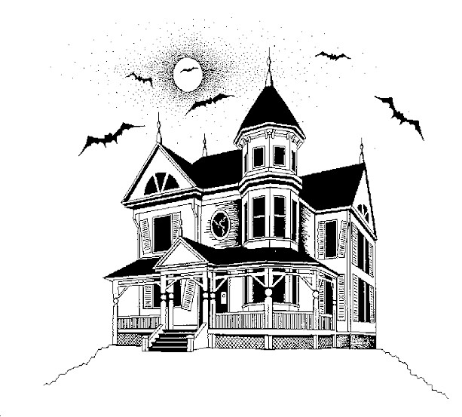

Criteria for Success:
Your ad starts with a lead, issue statement.
You state your main arguments using opinion statements.
You include “yes, but…” statements.
You include at least one rhetorical question.
You conclude with a call to action.

