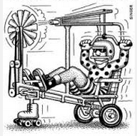
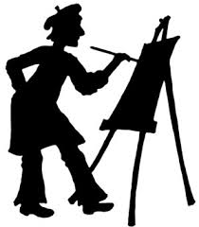
Artists and Inventors

Throughout our ELA unit on artists and inventors you have learned how they inspire us. Waterhouse Hawkins made some of the first molds of dinosaurs, Mahalia Jackson was one of the best blues singers and Leonardo da Vinci made many beloved pieces of art and was quite the inventor as well. Many more men and women from around the world have made other major contributions in science or in the arts that have enriched our society.

As part of our ELA unit you are going to design a Biography Scrapbook Report on a scientist or artist of your choice. The requirements for this project are:

- You will develop your project on 2 scrapbook pieces of paper – cut down to 8 ½ x 11 inches so they will fit into your Fifth Grade Binder.
- You must write your notes on the fact sheets in fragments not sentences
- You must organize your facts into categories, glue them onto the category sheet in a logical order and then organize each category sheet in sequential order.

Your presentation must include….
_______ a time-line of your inventor/artist’s life which will include his/her date of birth and death (if applicable), and significant events in his/her life which lead him/her to be the influential person that he/she became. This time-line can be in any form you wish.

______ You must have at LEAST 8-10 significant events

______ 3-5 pictures/visuals with captions

______ the inventor/artist’s name must be prominently displayed

_______ Additional or interesting fact that you learned about this person while researching.

The rest…..your creativity!!!

You can use stickers, clipart, drawings, borders….use your imagination to make your creation both informative and pleasing to look at!

Keep in mind that all final products should be proofread by both yourself and then an adult for grammar/spelling errors and written NEATLY in pen or typed. Also, staples and pieces of tape showing don’t give products a finished and neat look!! **

